**Module 1 Quiz**

**TOTAL POINTS 10**

1.

Question 1

Select the jobs below that may use SQL in their work (select all that apply).

1 point



Data Analyst



DBA



Backend Developer



QA Engineer



Data Scientist

2.

Question 2

How does a data scientist and DBA differ in how they use SQL?

1 point



Data scientists only query the database and don’t create tables.



DBA’s are the only ones who merge datasets together.



Data scientists don’t write complex queries.



DBAs manage the database for other users.

3.

Question 3

Which of the following statements are true of Entity Relationship (ER) Diagrams?

1 point



They speed up your querying time.



They only represent entities in the diagram.



They identify the Primary Keys



They show you the relationships between tables.



They usually are represented in a visual format.



They are usually a representation of a business process.

4.

Question 4

Select the query below that will retrieve all columns from the customers table.

1 point





SELECT (*) FROM customers





1

RETRIEVE * FROM customers





1

SELECT * FROM customers





1

2

3

4

5

6

7

8

9

SELECT

FirstName

,LastName

,Address

,City

,State

,ZipCode

,PhoneNumber

FROM customers

5.

Question 5

Select the query that will retrieve **only** the Customer First Name, Last Name, and Company.

1 point





1

2

3

4

5

6

SELECT

FirstName

,LastName

Company

FROM customers





1

2

3

4

5

6

SELECT

FirstName

LastName

Company

FROM customers





1

SELECT * FROM customers





1

2

3

4

5

6

SELECT

FirstName

,LastName

,Company

FROM customers

6.

Question 6

The ER diagram below is depicting what kind of relationship between the **EMPLOYEES** and **CUSTOMERS** tables?

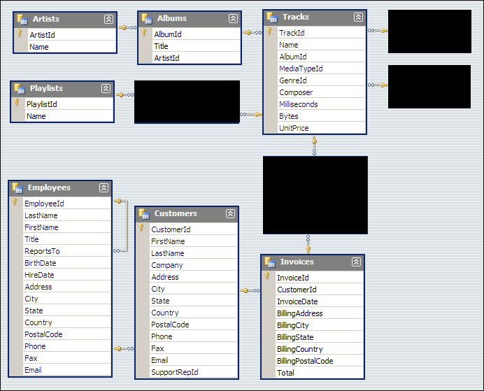

1 point



One-to-one



One-to-many



Many-to-one



Many-to-many

7.

Question 7

The data model depicted in the ER diagram below could be described as a _______________.



1 point



Transactional Model



Star Schema



Relational Model

8.

Question 8

When using the "CREATE TABLE" command and creating new columns for that table, which of the following statements is true?

1 point



You can create the table and then assign data types later



You must assign a data type to each column



You must insert data into all the columns while creating the table

9.

Question 9

Look at the values in the two columns below. Based on the values in each column, which column could potentially be used as a primary key?

|  |  |
| --- | --- |
| Column 1 | Column 2 |
| 5 | 2 |
| 6 | 4 |
| 1 | 5 |
| 2 | 5 |
| 34 | 32 |
| 8 | 6 |
| 9 | 4 |

1 point



Column 1



Column 2



Column 1 **OR** Column 2

10.

Question 10

In order to retrieve data from a table with SQL, every SQL statement must contain?

1 point



WHERE



FIND



CREATE



SELECT